LAB-3

1. Write a C programe using the pipe that perfrom following work:
   1. Parent: Ask two no from user and pass the number to child process.
   2. Child: add the numbers recvied from the parent and pass the result to parent.
   3. Parent: print the table of output received from child.

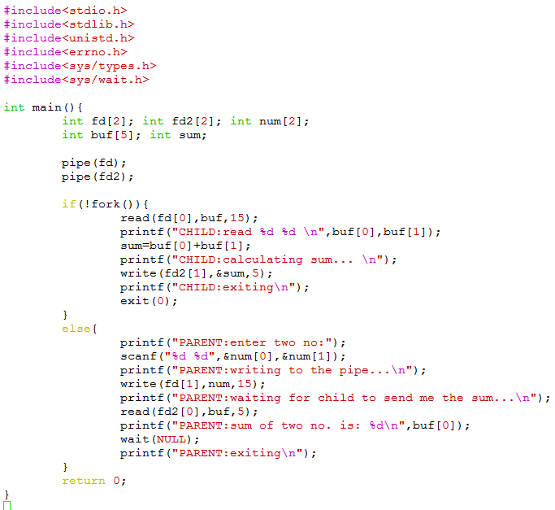

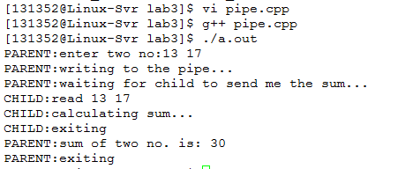

1. Write a C programe using the fifo that perfrom following work:
   1. Parent: Ask a string from user and pass the string to child process.
   2. Child: check the string (recvied from the parent) is palindrome or not and pass the result to parent.
   3. Parent: print the output received from child on the screen.

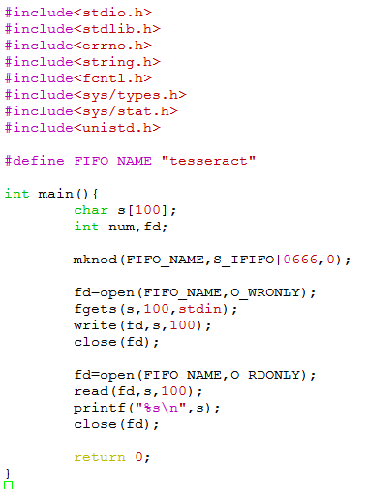

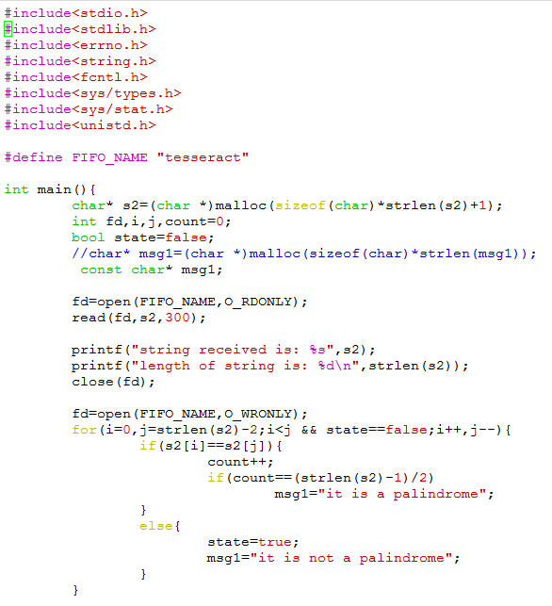

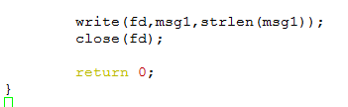

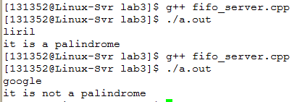

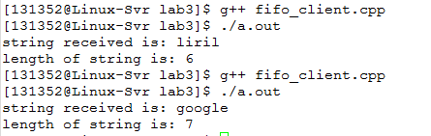

LAB-4

Shared Memory

Q. Write a C program using shared memory. Processes will perform following task:

Parent: Ask a string from User and pass it to child process using shared memory.

Child: Read the string from shared memory and reverse it. Pass the reversed string to Parent process.

Parent: Read the string from shared memory and print it on screen

